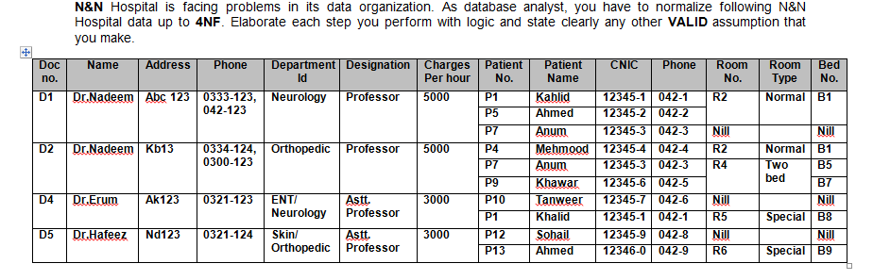

* Normalise the above table upto BCNF.
* Identify and mention the appropriate dependencies in each level of normalization.
* After every normalization level, illustrate the resulting tables with all values
* Elaborate each step clearly and mention any assumption you make to solve the problem.
* Answers can either be submitted as scanned copies of normalization done on paper or as documents where the tables are drawn using tools

[For better view of tables, click here](https://docs.google.com/spreadsheets/d/1W34z4UCC8SJBUVzumbzRl8S6mNSUICT-v0TwjGXhHb4/edit?usp=sharing)

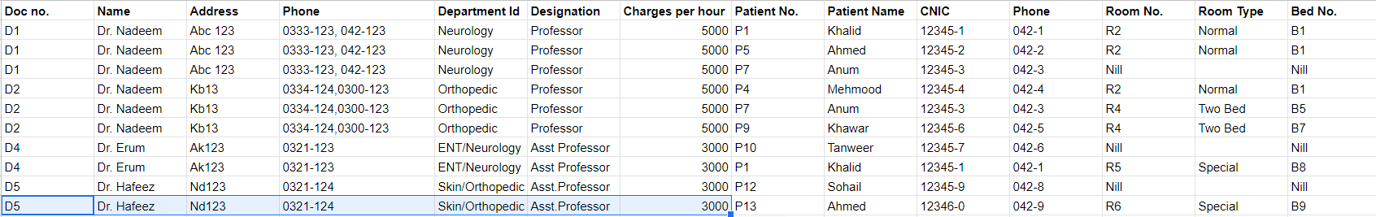

Clearly for the above table **Doc No** + **Patient No.** is the primary key

**Conversion to 1NF**

**attribute values should be atomic(not multivalued,composite)**

**Phone**,**Department Id** are multivalued attributes

Table 1

**Doc no**. + **Patient No.** + **Phone** is the primary key

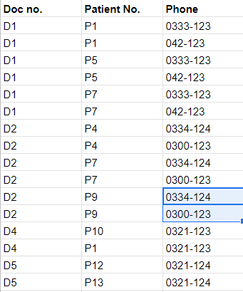

Table 2

**Doc no**. + **Patient No.** + **Department Id** is the primary key

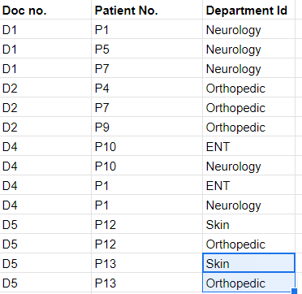

Table 3

**Doc No.** + **Patient No**. is the primary key

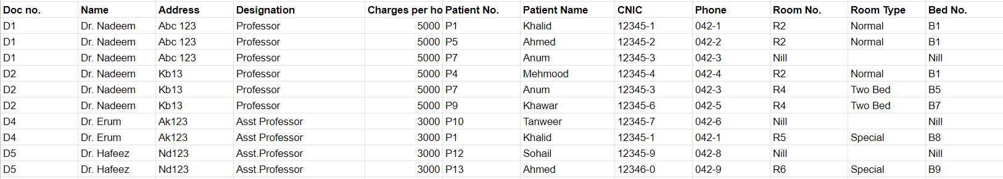

**Conversion to 2NF**

**Partial CK ---> NK (partial dependency) is not allowed**

In table 1, table 2 there are no non-key attribute ⇒ already in 2NF

In table 3,

We can assume the following FDs:(although we can never be too sure)

1)**Patient No**.--->**Patient Name**

2)**Patient No**.--->**CNIC**

3)**Patient No**.--->**Phone**

**4)Doc No.---> Address**

Here , **Patient No. , Doc No.** are part of Primary Key and **Patient Name**, **CNIC**, **Phone** , **Address** are non-key attributes

So FD 1,2,3,4 are partial dependencies

Table 4

**Patient No**. is the primary key

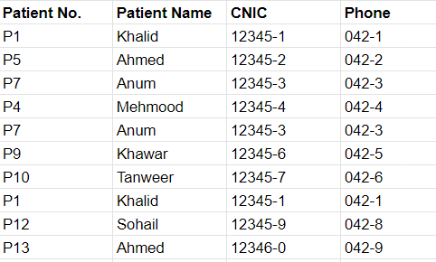

Table 5

**Doc no**. is the primary key

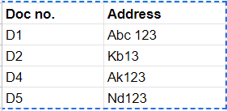

Table 6

**Doc no**. + **Patient No**. is the primary key

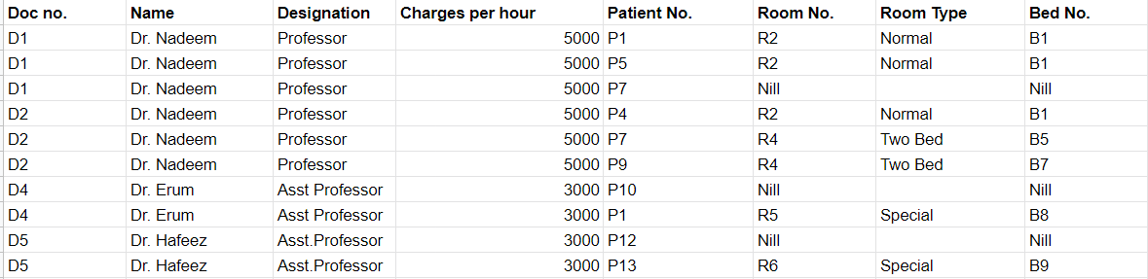

**Conversion to 3NF**

**NK-->NK (transitive dependency) is not allowed**

Table 4,5 is already in 3NF

In table 6,

We can assume the following FDs:(although we can never be too sure)

1)**Name** ---> **Charges per hour**

Table 7

**Name** is the primary key

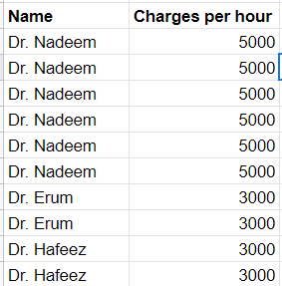

Table 8

**Doc No**. + **Patient No**. is the primary key

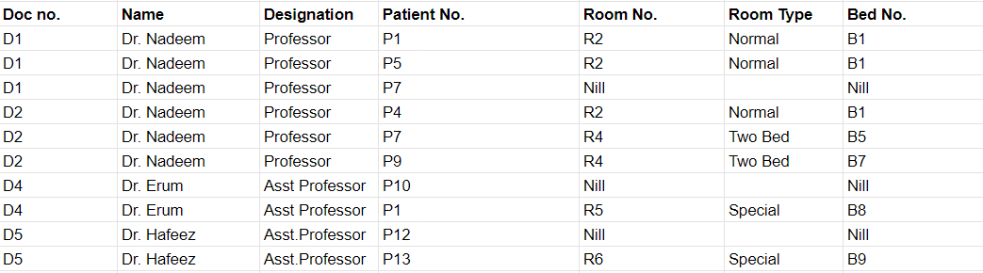

**Conversion to BCNF**

**NK--->CK is not allowed**

Table 7, 8 are already in BCNF